**Riphah International University**



**Alisha Ishrat**

**40851**

**Lab:5**

**CS-6**

**Task 1:**

The command: **nano file.** **c** is used to make c file in Linux.

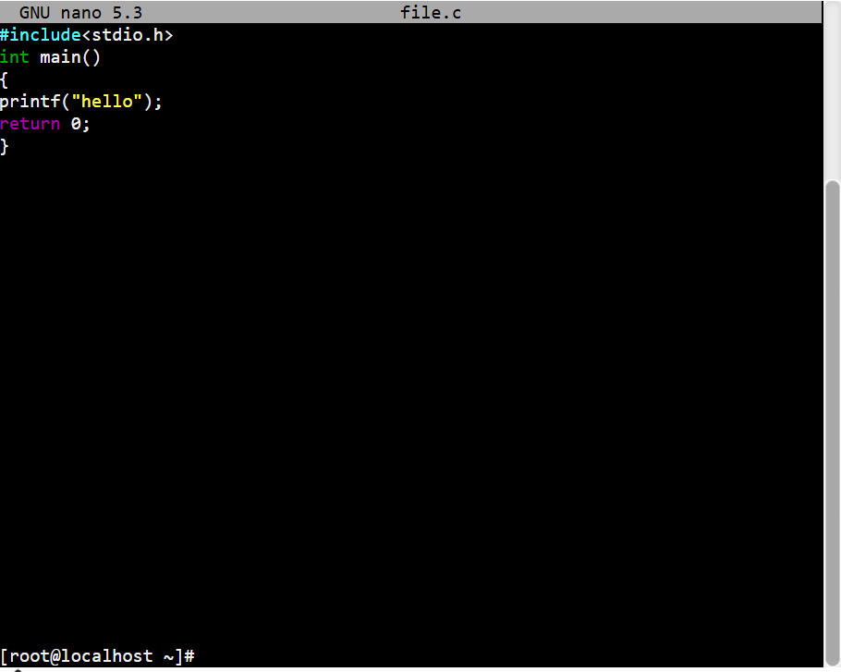

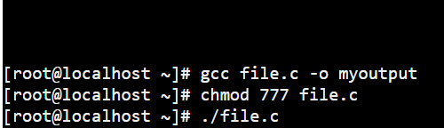

**Task 2:**

The **-o** option in the **gcc** command specifies that name of the output file. Without the **-o** option the **gcc** will create an executable file with a default name. So, when you use **-o** you can choose the name of the executable file.

**Example:**



**Task 3:**

The gcc is GNU complier collection for C. Used to compile C program but it can also compile C++ code with some extra flags. Its main purpose is for compiling C code. You can compile C code files with .c extension.

The g++ compiler collection for C++. Used to specifically compile C++ programs. It’s main purpose is for compiling C++ code. You can compile C++ code files with .cpp extension the g++ automatically links the C++ standard libraries.

**Task 4:**

First, we create a file. Command used:

**Nano file.cpp**

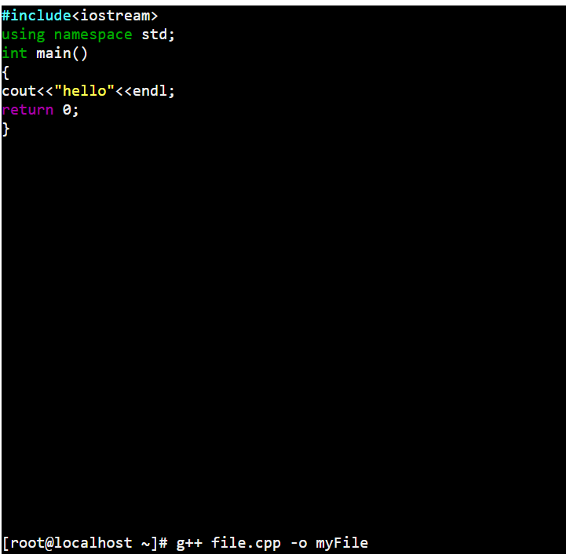

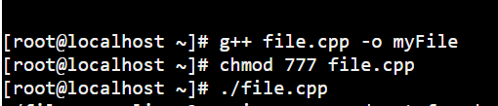

**Task 5:**

It is very useful and powerful feature allow you to write reusable code.

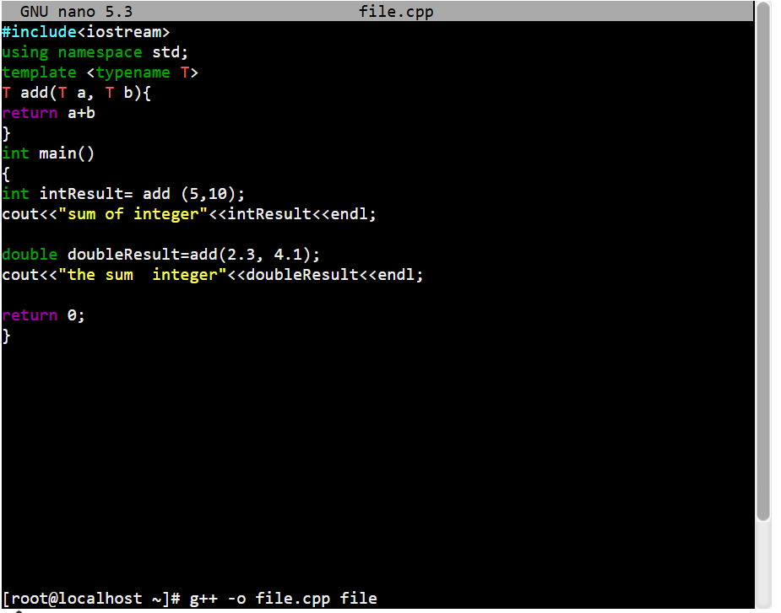

**Task 6:**

File Extension helps the operating system and user to identify the type of a file, a file with .c extension is recognized as a C source code file and a file with .cpp extension is indicates a C++ code file. This identification allows users, text editors and compilers to handle file appropriately.

**Task 7:**

Here is a common compilation error in C programming.

* **Syntax Error**

Missing of semicolon and brackets.

Check the line number in the error message and fix it.

* **Undeclared Identifiers**

Variables that are used in functions are not declared.

Make sure variables are declared before use.

* **Missing Header Files**

Not using/including necessary header files for function used.

Add appropriate header files at the top of the code.

* **Array Index Out of Bound**

Accessing an array element out of its defined range

Ensure values are within the range of an array.

**Task 8:**

Managing permissions for executable files is crucial for controlling who can read, write and execute files. In Linux each files and directory have three types of permissions:

**Read(r):** Allow viewing the content of file.

**Write(w):** Allow modifying or deleting the file.

**Execute(e):** Allow running the file as a program.

These permissions are assigned to three types of users:

**Owner:** A user who owns the file

**Group:** A group of users who can access the file.

**Others:** All other user on the system.

**Chmod Command:**

Chmod command is used to changes the permission of the file.

chmod 777 FileName is used to set permission to all read, write and execute and group, owner and others.

Numbers to Represent Permissions:

4= Read

2= Write

1= Execute

Symbol to Represent Permissions:

r= Read

w= Write

e= Execute

**Task 9:**

Tarball used in OS to compress files by using **tar** command. It is commonly used to package multiple files and directories into a single file.

**Limitations:**

In tarball if we use tar command then there is no way to manage software.

Hard to know which version of software you are using.

No idea which files are stored at what location.

Difficult to remove the software and upgrade it.

**Task 10:**

RPM is a default package installation. RPM stand foe RedHat Package Manager used in RedHat Linux. All required files are complied in single format. It is still not good enough to resolve dependencies. RPM significantly enhanced software management on Linux system as compared to tarballs by providing robust dependency management. While it have it’s limitation, especially in handling complex dependencies.